FOR IMMEDIATE RELEASE

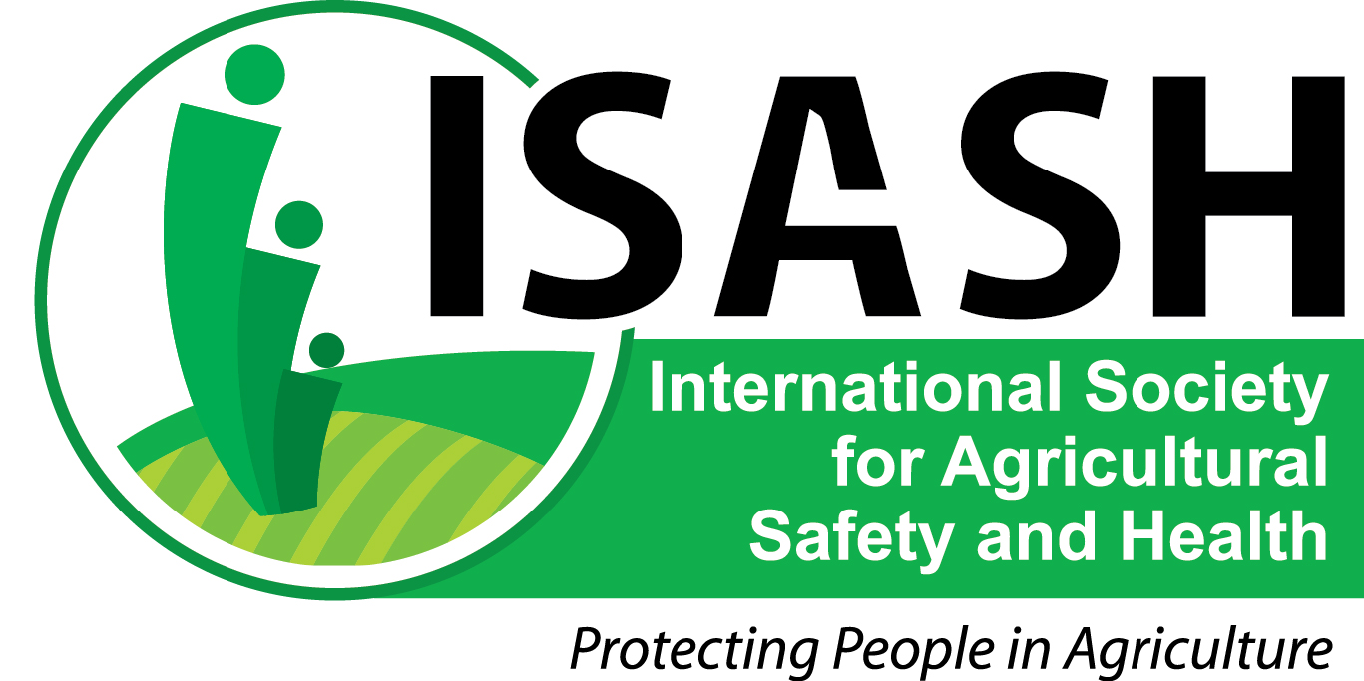

September 12, 2014

CONTACT: Scott Heiberger

[heiberger.scott@mcrf.mfldclin.edu](mailto:heiberger.scott@mcrf.mfldclin.edu)

715-389-7541

**Working together for safety in agriculture**

A secure, healthy food supply is everyone’s business, and so is the safety of farmers and farm workers.

The U.S.-based International Society for Agricultural Safety and Health (ISASH) urges consumers and everyone involved in agriculture to recognize National Farm Safety and Health Week (September 21-27) and promote awareness of safety solutions year round.

ISASH membership includes engineers, educators, insurers, physicians, nurses, veterinarians, statisticians, communicators, anthropologists, business leaders and others. Many of them have extensive farm and ranch backgrounds.

“This year’s safety week theme, ‘Safety counts: Protecting what matters,’ is best served by all of us working together to build a safer and healthier agricultural work place,” said ISASH President Risto Rautiainen, Ph.D., director, Central States Center for Agricultural Safety and Health, University of Nebraska, Omaha.

The total number of fatalities in the U.S. agriculture, forestry and fishing sector continue to decline, but the fatality rate remains the highest of any industry sector, according to preliminary data from the Census of Fatal Occupational Injuries, released Thursday by the U.S. Bureau of Labor Statistics. Fatalities decreased 6 percent to 479, the third straight year of declines. However, the sector’s injury rate was 22.2 fatal injuries per 100,000 workers in 2013, far ahead of transportation (13.1/100,000) and mining (12.3/100,000).

“These figures are especially relevant during harvest season, as farmers are putting in long hours under the stress of weather delays, equipment breakdowns and heavy workloads,” Rautiainen said. “We urge farmers to set priorities to reduce the risk of injury to themselves, their family and their employees.”

For more information on National Farm Safety and Health Week, and safety resources, visit the website of the National Education Center for Agricultural Safety, <http://www.necasag.org/>.

For more information about ISASH, including membership, go to [www.isash.org](http://www.isash.org), or contact ISASH Secretary Chip Petrea (217-333-5035, [repetrea@illinois.edu](mailto:repetrea@illinois.edu)), or President Risto Rautiainen (402-559-4998, [rrautiainen@unmc.edu](mailto:rrautiainen@unmc.edu)).

**2014-2015 ISASH Board of Directors:** Risto Rautiainen, University of Nebraska (president); Marcel Hacault, Canadian Agricultural Safety Association (president-elect); George Cook, University of Vermont; Scott Heiberger, National Farm Medicine Center; Peter Lundqvist, Swedish University of Agricultural Sciences; Deborah Reed, University of Kentucky; Natalie Roy, AgriSafe Network; Chris Shivers, Mississippi Farm Bureau Federation; Aaron Yoder, University of Nebraska. Ex-Officio to the board: Nancy Hetzel (treasurer); Chip Petrea, University of Illinois (secretary); David Hard, National Institute for Occupational Safety and Health (financial officer).

The next ISASH annual meeting will be held June 2015 in Bloomington-Normal, Ill.

###