FOR IMMEDIATE RELEASE
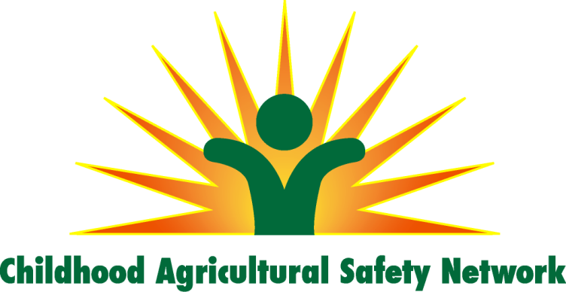
September 1, 2014

CONTACT: Scott Heiberger
heiberger.scott@mcrf.mfldclin.edu
715-389-7541

Tractor safety campaign challenges unsafe traditions

A child dies from injuries on a farm an average of once every 3.5 days. The most common situation involves a tractor.

“Keep Kids Away from Tractors,” is the unified message of the Childhood Agricultural Safety Network (CASN) http://www.childagsafety.org/, a coalition of 38 health, safety and youth organizations. The coalition’s campaign urges adults to think twice before allowing children 12-under to operate tractors or ride on them.

The coalition urges individuals and groups to incorporate CASN resources in their safety initiatives. Posters, radio ads and more information can be found at http://www.childagsafety.org/TractorCampaign.htm.

Consider these incidents from the past year:

- A 1-year-old North Dakota boy died after falling from a tractor driven by his father. His 4-year-old brother survived.

- A 6-year-old Minnesota boy died with his grandfather when the tractor they were riding rolled over.

- A 5-year-old Kansas girl died when she fell through the windshield of a combine driven by her father.

The biggest tragedy of all? These deaths were 100 percent preventable.

Allowing young children to ride on a tractor is considered a tradition by many. But remember -- “It’s easier to bury a tradition than a child.”

###

