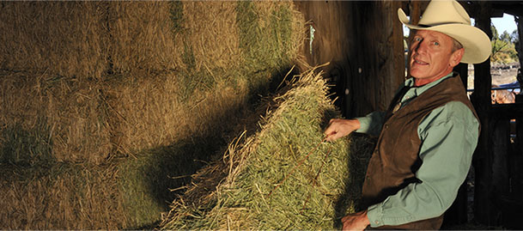  Safety Counts- Protecting What Matters  Amber D. Wolfe- AgrAbility Project Coordinator, Arthritis Foundation  Protecting What Matters: Joint Protection and Osteoarthritis on the Farm |  | National Farm Safety and Health Week  - September  - 20-27, 2014

Protect your joints. Whether you are working in the barn or driving farm machinery, it is important to minimize the trauma that joints experience.

It is important to identify your own body mechanics and capabilities, as well as your needs, before determining how to modify your work practices or adapt tools to better enable you to manage pain.
Body Positions

Drive comfortably. Your upper body should be comfortably spaced from your steering wheel. Your arms should not extend too far and your wrists should be turned at a normal angle.
Sit and stand. Neither sitting nor standing on your feet all day is good for you. When possible, alternate between the two to prevent locking yourself in one position.

Avoid a pain in the neck. Additional mirrors on machinery and in trucks can reduce strain on your neck and shoulders.
Lifting and Carrying

Handle heavy loads. To move moving feed bags or seed, use your largest, strongest joints and muscles to take stress off smaller hand joints. When you lift or carry items, use the palms of both hands or use your arms instead of your hands. Hold items close to your body, rather than you’re your shoulders, which is more stressful for your joints. Slide objects whenever possible rather than lift them.

Organization

Arranging your tasks in a natural order and time around your farm prevents unnecessary backtracking and tiredness.

Assistive Devices
Using walking or assistive devices can keep stress of off injured or overused joints. Use tools with thicker grips and longer handles. Visit “The Toolbox AT database” for over 1,000 approved devices- http://www.agrability.org/Toolbox/
Weight Control

Resolve to reduce. Lose weight. Every extra pound you gain puts four times the stress on your knees. Research has shown that losing as little as 11 pounds may improve your joint health and cut your risk of osteoarthritis of the knee by 50 percent.
Additional Information
- www.agrability.org
- www.arthritis-ag.org
- awolfe@arthritis.org
- 1-800-783-2342

